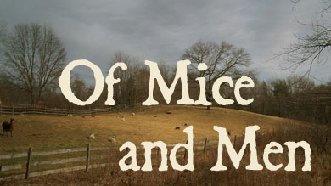
By John Steinbeck

Student Work Book

Name: _____________________________

Block: _______________
Discussion Questions
As you read each chapter of the novel, be prepared to answer the corresponding questions. These questions will be used to focus class discussion and develop your understanding of the novel. Jot down point form answers to help your memory.
Chapter 1: George and Lennie
- Identify and give a physical description of Lennie and George.
- What is George's first complaint to Lennie?
- What trouble did George and Lennie have in Weed?
- What is in Lennie's pocket? Why does he have it?
- George bursts into a long speech about what he could do if he were alone. What could he do?
- Lennie offers to go away and live in a cave. What is George's response?
- Why are George and Lennie different from the other "guys like us that work on ranches"?
- What are George and Lennie going to do someday?
- What two things does George want Lennie to remember?
- Why did George want to camp overnight instead of going another quarter of a mile to the ranch?
Chapter 2: The Ranch
- What kind of work are George and Lennie going to do?
- What does George answer when the boss asks what he is trying to put over?
- Identify and describe Curley.
- The swamper said, "seems like Curley ain't givin' nobody a chance." Explain.
- What advice does George give Lennie after Curley and the swamper leave?
- Identify Slim and Carlson.
- What does Slim have that Lennie wants?
Chapter 3: The Bunkhouse
- Slim and George have a long conversation. Slim says it's funny how George and Lennie go around together. What is George's answer?
- Identify and describe Candy.
- What did Carlson do with his Luger. Why?
- What card game does George play?
- Describe Curley's wife. What's the problem about her?
- What will Lennie's job be when he and George get their land?
- What does Candy want when he hears about George's and Lennie's plans? What is he willing to contribute?
- Why did Curley fight with Lennie? What happened?
Chapter 4: Crooks
- Identify and describe Crooks.
- Lennie tells Crooks about the land. What is his reply at first?
- What does Crooks want when he believes there might really be land?
- Why is Crooks ostracized from the rest of the men? How does this make him feel?
- Why did Curley's wife come to the barn?
- Why did Crooks change his mind after Curley's wife left?
Chapter 5: Lennie
- What happened to Lennie's puppy? What is his reaction?
- Why did Curley's wife come to see Lennie?
- What did she tell Lennie?
- Why did Lennie kill Curley's wife?
- What was George's reaction when he found out about Curley's wife's death?
- What was Curley's reaction to his wife's death?
Chapter 6: Chase
- Where has Lennie gone and why?
- Who does he see there?
- What does George do to Lennie? Why? What other incident in the novel does this parallel?
- Who is the only one who really understands what George did?
- Did George do the right thing? Why or why not?
Vocabulary Building
Chapter 1
Finding the Right Meaning
Directions:
In the sentences below, the vocabulary words have been under-lined. Under each sentence are four choices of definitions. Cirlce the letter of the correct choice.

- After the destructive flooding, much debris remained along the river bank.
- valuable ore c) scattered waste
- foamy water d) bare rock

- As Lennie tried to memorize George's instructions, he droned to himself softly.
- repeated dully c) called shrilly
- hummed again d) whispered slowly

- The sycamores' recumbent branches arched low across the pool, nearly touching its surface.
- crooked c) reclining
- colorful d) thick

- Lennie contemplated running away when George told him to give up the dead mouse.
- forgot c) denied
- started d) considered

- George morosely gazed at the fire, feeling discouraged at being burdened with Lennie.
- Glumly c) silently
- Carefully d) steadily

- Pretending not to have a dead mouse in his pocket, Lennie made a pantomime of innocence.
- Spirited defense c) serious vow
- Wordless show d) long speech

Vocabulary Building
Finding the Right Meaning
Chapter 1

- Feeling it his duty, George resignedly told Lennie where they were going.
- forcefully c) absentmindedly
- acceptingly d) angrily

- In his usual clumsy manner, Lennie lumbered into the brush to get wood for the fire.
- hiked c) moved heavily
- darted d) limped

- George put out his hand imperiously to Lennie, demanding that Lennie give up the mouse.
- selfishly c) carelessly
- knowledgeably d) commandingly

- George took three cans of beans from his bindle, then retied his pack.
- blanket role c) stockpile
- broad-brimmed hat d) belongings

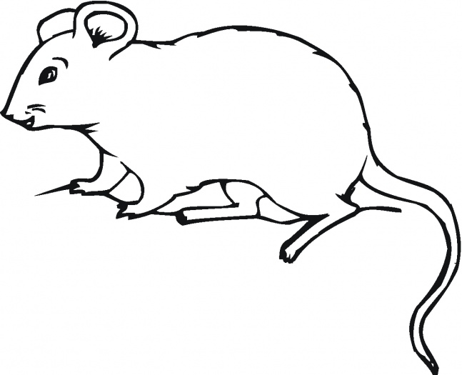

Literary Skills
Chapter 1 – Characterization
Sketching a Portrait
Steinbeck introduces his two main characters in this chapter, creating a first impression of George's and Lennie's looks, personalities, beliefs, and dreams.
Sometimes authors use direct characterization to describe characters – that is, they will directly tell readers important information about a character. For example, an author might write, "Margo was an extremely generous person."
However, in this novel, Steinbeck prefers to use indirect characterization. In other words, we learn about characters by interpreting clues that Steinbeck gives.
Steinbeck tells us about his characters in the following ways:
- He describes their appearances.
- He shows their actions.
- He quotes their explanations of their own actions.
- He quotes their expressions of how they believe and feel.
- He gives clues from what others say to or about a character.
Directions
For each passage below, use the list above to identify the method Steinbeck uses to give information about the character(s). Then tell what you learn about the character(s) from that passage. An example has been done for you.
Example:
They [George and Lennie] had walked in single file down the path, and even in the open one stayed behind the other.
- Method: B
- What you learn: George is the leader: Lennie is the follower

- [Lennie] drank with long gulps, snorting into the water like a horse.
- Method: _____
- What you learn:

- The first man was small and quick, dark of face, with restless eyes and sharp, strong features.
- Method: _____
- What you learn:

Literary Skills: Characterization
Sketching a Portrait

Chapter 1

- "Lennie," he said hopelessly. "You'd drink out of a gutter if you was thirsty."
- Method: _____
- What you learn:

- Lennie … imitated George exactly. He pushed himself back, drew up his knees, embraced them, looked over to George to see whether he had it just right.
- Method: _____
- What you learn:

- "I forgot," Lennie said softly. "I tried not to forget. Honest to God I did, George."
- Method: _____
- What you learn:

- His anger left him suddenly. He looked across the fire at Lennie's anguished face, and then he looked ashamedly at the flames.
- Method: _____
- What you learn;

- Behind him walked his opposite, a huge man, shapeless of face, with large, pale eyes, with wide, sloping shoulders…
- Method: _____
- What you learn:

- "When I think of the swell time I could have without you, I go nuts. I never get no peace."
- Method:_____
- What you learn:
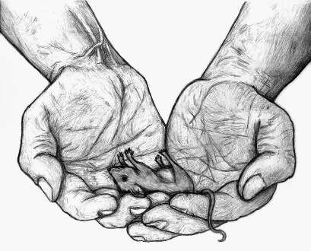
Literary Skills
Chapter 2 Foreshadowing and Prediction

Clouds on the Horizon

Steinbeck provides hints about what will happen later in the story. This technique of giving clues to prepare readers for later events is called foreshadowing.
Foreshadowing serves several purposes. It can arouse the reader's curiosity, piquing interest in details and creating an eagerness to continue reading. It can also make later events seem more believable since the author has already hinted at the outcome.
A writer who uses forshadowing doesn't necessarily give away the story. A reader must still interpret the cliues and predict what will happen.

Directions
Analyze the following examples of foreshadowing from Chapters 1 and 2. (The chapter number for each example is indicated in parentheses). Then make a prediction based on each clue.

- Foreshadowing: Lennie has a habit of killing the mice he pets. (1)
Prediction: _____________________________________________________________
_______________________________________________________________________

- Foreshadowing: George and Lennie had to flee Weed when Lennie tried to feel a girl's dress. (1)
Prediction: _____________________________________________________________
_______________________________________________________________________

- Foreshadowing: George tells Lennie to come back to the river and hide in the brush if anything goes wrong. (1)
Prediction: _____________________________________________________________
_______________________________________________________________________

- Foreshadowing: The boss is very angry when George and Lennie don't turn up when he expected them to. (2)
Prediction: _____________________________________________________________
_______________________________________________________________________

- Foreshadowing: When Curley sees George and Lennie, his hands close into a fist. (2)
Prediction: _____________________________________________________________
_______________________________________________________________________

- Foreshadowing: The old swamper says that Curley's wife has "got the eye". (2)
Prediction: _____________________________________________________________
_______________________________________________________________________

- Foreshadowing: Lennie wants to leave the ranch, but George tells they must stay. (2)
Prediction: _____________________________________________________________
_______________________________________________________________________

- Foreshadowing: The old swamper says that Curley's wife has "got the eye". (2)
Prediction: _____________________________________________________________
_______________________________________________________________________

- Foreshadowing: Carlson suggests shooting Candy's useless old dog to put it out of its misery. (2)
Prediction: _____________________________________________________________
_______________________________________________________________________

- Foreshadowing: George is afraid that he will tangle with Curley. (2)
Prediction: _____________________________________________________________
_______________________________________________________________________

Vocabulary Building
Chapter 3
Context Clues
Directions: Choose a word from the vocabulary list in the box to correctly complete each sentence. Write the correct word in the blank.
receptive bemused scuttled
subsided rapidly reprehensible
wryly welled derision
subdued

- The ranch hands were quick to voice their _______________________ at the horse-shoe players' lack of skill.

- Enjoying the chance to put Curley in his place, Slim smiled ______________________ as he instructed Curley to be quiet about the fight with Lennie.

- Slim's inviting _______________________ manner eventually led George to confide in him about the events in Weed.

- Trying to regain control and steady himself, Slim _______________________ one nervous hand with the other.

- When George warned Lennie to return the puppy to the barn before Lennie killed it Lennie _______________________ out of the room.

- To be overheard discussing their dream seemed _______________________, and George reacted with guilt and anger.

- As George shared their plans with Candy, George became so engrossed in them that he stared _______________________ at the wall.

- After his initial outrage at the thought of cats harming his rabbits, Lennie managed to calm down and eventually his anger _______________________.

- Stunned by the sudden possibility of actually achieving their dream, George, Lennie, and Candy were _______________________ and amazed.

- When Curley struck Lennie, the blood _______________________ from Lennie's nose and quickly covered his face.
Literary Skills
Chapter 3 Figurative Language
Word Power
For the most part, Of Mice and Men is told in simple, straightforward language. Yet occasionally Steinbeck includes colorful similes and metaphors.
A simile is a direct comparison using the words "like" or "as." "The hail pounded on the roof like hundreds of hammers" is an example of a simile.
A metaphor implies a comparison without using the words "like" or "as." "A banner of color announced the end of the rain" is an example of a metaphor. The implied comparison is between a rainbow and a colorful banner.
Steinbeck uses figurative language to add spice to the narration and to give his words and extra level of meaning by making revealing comparisons.
Directions:
Decide whether a simile or metaphor is being used in each of the following examples. (The chapter where each example can be found is noted in parentheses.) Then explain what two things are being compared.

- On the sand banks the rabbits sat as quietly as little gray, sculptured stoned. (1)
- Figure of speech __________________________________________________
- The comparison is between __________________________________________

- A water snake slipped along on the pool, its head held up like a little periscope. (1)
- Figure of speech __________________________________________________
- The comparison is between __________________________________________

- "He's [Lennie's] jes' like a kid, ain't he." (3)
a. Figure of speech __________________________________________________
b. The comparison is between __________________________________________

- The sun square was on the floor now, and the flies whipped through it like sparks. (2)
a. Figure of speech __________________________________________________
b. The comparison is between __________________________________________

- George warns Lennie that Curley's wife is a "rat-trap if I ever seen one." (2)
a. Figure of speech __________________________________________________
b. The comparison is between __________________________________________

- [Slim] moved with a majesty… He was a jerkline skinner, the prince of the ranch. (3)
a. Figure of speech __________________________________________________
b. The comparison is between __________________________________________

- Slim's hands are described as "large and lean… as delicate in their action as those of a temple dancer." (2)
a. Figure of speech __________________________________________________
b. The comparison is between __________________________________________

- Curley stepped over to Lennie like a terrier. (3)
a. Figure of speech __________________________________________________
b. The comparison is between __________________________________________

- Lennie covered his face with his huge paws and bleated with terror. (3)
a. Figure of speech __________________________________________________
b. The comparison is between __________________________________________

- The next minute Curley was flopping like a fish on a line. (3)
a. Figure of speech __________________________________________________
b. The comparison is between __________________________________________

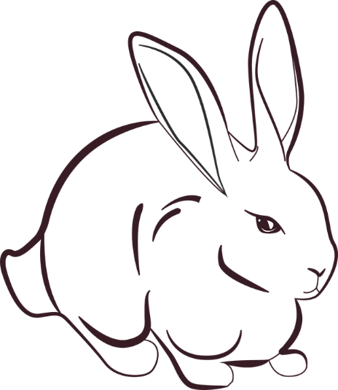

Literary Skills: Figurative Language
Word Power: Chapter 3

One Step Further
Frequently in Of Mice and Men, Lennie is compared to an animal. Examine this comparison. Address questions like these:
- In what circumstances is Lennie compared to an animal?
- What kind of animal is he compared to?
- What impression is created by these comparisons?
- How are animals in the novel regarded and treated? What does this imply about Lennie?

Cite examples from the novel to back up your points.

______________________________________________________________________________
______________________________________________________________________________
______________________________________________________________________________
______________________________________________________________________________
______________________________________________________________________________
______________________________________________________________________________
______________________________________________________________________________
______________________________________________________________________________
______________________________________________________________________________
______________________________________________________________________________
______________________________________________________________________________
______________________________________________________________________________
______________________________________________________________________________
______________________________________________________________________________
______________________________________________________________________________
______________________________________________________________________________
______________________________________________________________________________
______________________________________________________________________________
Literary Skills
Chapter 3 Conflict

Push Comes to Shove
Conflict is an inescapable part of the ranch hands' lives. Just as the animals in the surrounding mountains must compete for food and survival, so the characters of Of Mice and Men must fight with each other for what they want and need.
Conflict occurs in a story when a character confronts an opposing force. There are five main types of conflict.
- character vs. character – a character or characters face a problem with one or more characters in the story
- character vs. self – a character faces a physical or emotional struggle
- character vs. society – one or more characters face a problem with a part of society (government, laws, traditions, etc.)
- character vs. nature – one or more characters face a problem with a force of nature (storm, heat, cold, etc.)
- character vs. fate – one or more characters face a problem with a force such as fate, God, or luck
Directions:
List one conflict that arises in each of the following situations. After you list the conflict, explain who or what is involved. See the example below. Though some passages will reflect several conflicts, you only have to identify one. An example has been done for you.

Example
Lennie loves petting soft animals but always ends up killing them when they bite him.
a. Type of conflict: character vs. nature (or character vs. self)
b. Forces involved in the conflict: Lennie vs. animals (or Lennie's attraction to soft things vs. inability to control himself

1. George explains that he used to play jokes on Lennie who was too dumb to know the difference, but he stopped after Lennie nearly drowned.
a. Type of conflict ____________________________________________________
b. Forces involved in conflict ___________________________________________
____________________________________________________________________

2. George makes Lennie return the pup to the barn.
a. Type of conflict ____________________________________________________
b. Forces involved in conflict ___________________________________________
____________________________________________________________________

3. Candy tried to reject Carlson's argument that Candy's old dog is better off dead.
a. Type of conflict ____________________________________________________
b. Forces involved in conflict ___________________________________________
____________________________________________________________________

4. Slim has second thoughts about not intervening to save Candy's dog.
a. Type of conflict ____________________________________________________
b. Forces involved in conflict ___________________________________________
____________________________________________________________________

5. The swamper says Curley hates big guys because Curley isn't big himself.
a. Type of conflict ____________________________________________________
b. Forces involved in conflict ___________________________________________
____________________________________________________________________

6. Curley interrupts the men in the bunk house while searching for his wife, who he suspects might be there.
a. Type of conflict ____________________________________________________
b. Forces involved in conflict ___________________________________________
____________________________________________________________________

7. George reveals to Slim that he and Lennie fled Weed because Lennie was accused of rape and a lynch party was searching for them.
a. Type of conflict ____________________________________________________
b. Forces involved in conflict ___________________________________________
____________________________________________________________________
Vocabulary Building
Chapter 4

Vocabulary Analogies
Analogies are a shortened way of stating relationshops between words and ideas.
A common type of analogy expresses the relationship between synonyms. Below is an example:
skim : scan : : bargain : negotiate
This means the relationship between skim and scan is the same as the relationship between bargain and negotiate. (The symbol ":" means "is to" and the symbol ": :" means "as.")
An analogy may also involve antonyms. Look at the one below:
Simple: complex : : learned : uneducated
Another way to state this analogy is simple is to complex as learned is to uneducated.

Directions
Complete the analogies by using the appropriate synonym or antonym in the box below.
accumulated appraised meager
aloof disarming averted
contemptuously sullenly crestfallen
fawning

- skeptical : trusting : : sociable : ________________________________________
- scuttled : scurried : : gathered : ________________________________________
- derogatory : insulting : : disappointed : __________________________________
- pugnacious : peaceful : : plentiful : ______________________________________
- level : sturdy : : charming : ____________________________________________
- plaintively : joyful : : respectfully : ______________________________________
- subdued : controlled : : evaluated : _____________________________________
- contemplated : pondered : : turned away : _______________________________
- morose : melancholy : : flattering : ______________________________________
- imperiously : meekly : : cheerfully : ____________________________________
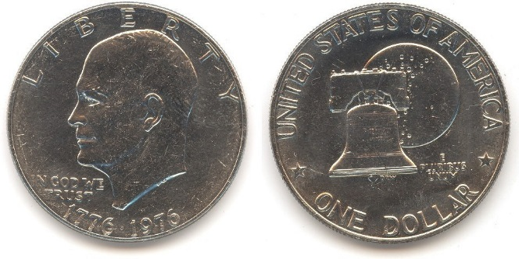
Literary Skills
Chapter 4 Round Characters

Two-Sided Coins
Like a coin, many of Steinbeck's characters are round characters, with more than one "face."
Anyone who has read a fairy tale is familiar with flat characters. The wicked witch, the brave prince, and the good godmother are all one dimensional characters. They always act the same way, never changing or growing.
Most novelists prefer to create round characters. These characters have different sides, conflicting emotions, and emotional depth. With their realistic dimensions, these characters engage a reader's belief, interest, and even sympathy.

Directions:
For each statement below, find evidence to support it (pro). Then find evidence from the book that shows the opposite about the character (con). Finally, draw a conclusion about the character on the basis of your evidence. An example has been done for you:

Example
Curley's wife is powerless.
- Pro: Curley's wife is stranded at the ranch. She knows that her husband is in town and can't do anything about it.
- Con: Curley's wife makes the men uneasy. She is the boss's daughter-in-law, and she can drive Curley crazy with jealously.
- Conclusion: Curley's wife is powerless to change her own circumstances, but she can affect others.

- George is a realist:
- Pro: ________________________________________________________________
_______________________________________________________________________
- Con:________________________________________________________________
_______________________________________________________________________
- Conclusion: __________________________________________________________
_______________________________________________________________________
- Candy is weak and useless.
  - Pro: ______________________________________________________________ __________________________________________________________________
  - Con:______________________________________________________________
__________________________________________________________________
  - Conclusion: _______________________________________________________
__________________________________________________________________

- George could live a better life without Lenny.
- Pro: _____________________________________________________________ __________________________________________________________________
- Con:______________________________________________________________
__________________________________________________________________
- Conclusion: _______________________________________________________
__________________________________________________________________

- Curley is cocky and self-assured.
  - Pro: _____________________________________________________________ ________________________________________________________________
  - Con:______________________________________________________________ _________________________________________________________________
  - Conclusion: _______________________________________________________
________________________________________________________________

- Lennie is poor at "reading" and manipulating people.
  - Pro: _____________________________________________________________ ________________________________________________________________
  - Con:______________________________________________________________ _________________________________________________________________
  - Conclusion: _______________________________________________________
________________________________________________________________

- Curley's wife lives in a dream world.
  - Pro: _____________________________________________________________ ________________________________________________________________
  - Con:______________________________________________________________ _________________________________________________________________
  - Conclusion: _______________________________________________________
________________________________________________________________

- Slim is trustworthy and unfailingly right.
  - Pro: _____________________________________________________________ ________________________________________________________________
  - Con:______________________________________________________________ _________________________________________________________________
  - Conclusion: _______________________________________________________
________________________________________________________________
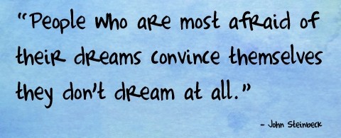

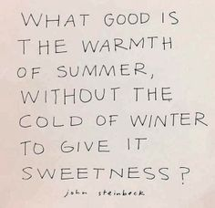
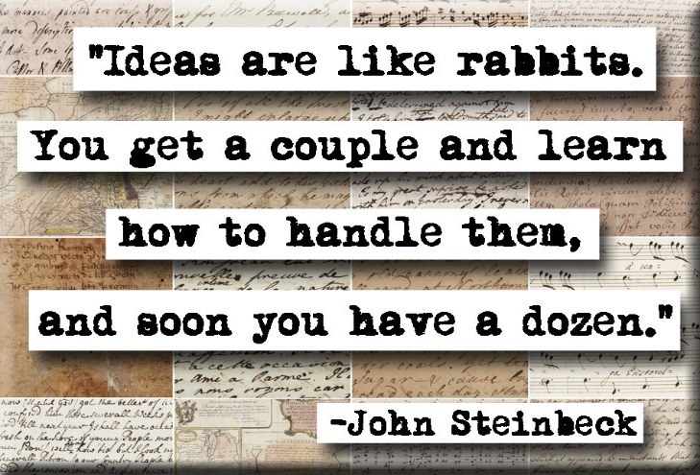

Literary Skills
Culminating Activity Plot Structure
- Pyramid of Action
The plot of Of Mice and Men consists of several episodes, or separate incidents. These episodes are connected so that the plot flows smoothly.

Of Mice and Men breaks down into the traditional five-part structure.

  - exposition—an introduction to the mail characters, settings, and situations of the plot
  - rising action—the events and complications that lead to an important and dramatic point in the plot
  - climax—the point of greatest interest and emotional involvement in the plot
  - falling action—the events that develop from the climax and lead to the conclusion
  - resolution or denouement—the final outcome that ties up any loose ends left in the story
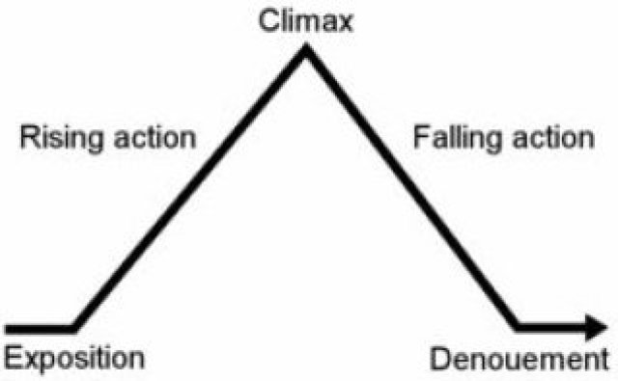
The structure can be depicted as a pyramid, with two base lines.

Directions:
Below is a list of major episodes in Of Mice and Men. Copy these episodes on the chart (on the next page) in the order in which they occur.

After you finish putting the events in proper order, turn the diagram sideways and draw the pyramid diagram (draw over your answers) to reflect where the five elements of the plot occur. Then label the parts of the pyramid. Use a colored pen or pencil for your lines and labels.
Note: your pyramid might look lopsided (one side longer than the other)
Major Episodes
- Carlson shoots Candy's dog
- George shoots Lennie
- Lennie kills Curley's wife
- George and Lenny camp by the green pool
- Lennie breaks Curley's hand
- The men organize a lynching party
- Candy offers to add his savings so George and Lennie can buy the farm
- Crooks asks to join the others in the farm venture and then backs out
- George predicts trouble with Curley and warns Lennie to stay away from Curley's wife
- The men catch up to George
10 | resolution
9
8
7
6
5
4
3
2
1 | exposition

Expressing Loneliness
Directions
In varying degrees, many of the characters Of Mice and Men reveal their loneliness. In your group, divide the characters for your research. Complete the chart by finding in the novel, narrative or dialogue revealing the loneliness of each of the characters named below
Name of Character | Supporting Evidence
George
Lennie
Slim
Curley's Wife
Crooks
Candy
Evaluation: Of Mice and Men Student Workbook
Learning Targets:
- Read, consider and analyze the topic, themes and features of the novel.
- Reflect on the writing style, tone, topics, and use of rhetorical devices in order to understand the play, its characters, themes and issues.
- Make individual thinking and understanding visible through accurate completion of tasks
As you self-assess, please highlight areas/sticky-note pages to show evidence.
Criteria |  | Not Yet Meeting Expectations | Minimally Meeting Expectations | Fully Meeting Expectations | Exceeding Expectations
Use strategies to construct meaning  Evaluate/analyze/interpret texts  Increase word skills and vocabulary |  | At least 25% of analysis work is not complete or completed very poorly  No evidence | Most or all sections are filled in (perhaps some better than others)  Some use of evidence | Each section is filled out well, with specific notes  Evidence often cited | Each section is completed with detail, with clear notes and observations  Specific evidence cited when needed
Synthesize and extend thinking about texts  Recognize and explain structures and devices in text  Appreciate the writer's craft by analyzing text structure and feature |  | Answers are inaccurate or very obviously rushed; little to no thought demonstrated in completion. | Answers are often accurate, although there may be some omission or error present. Work may feel rushed. | Answers are accurate and show that the student worked to determine correct answers. | Answers are very accurate and demonstrate thoughtful consideration of questions.
Student Achievement |  | Not there yet. Student must revise work so that it shows satisfactory understanding | 3- 3 4  NOVICE | 4+ 5- 5  PROFICIENT | 5+ 6- 6  MASTERY
Work Habits | Good: submitted on time/all questions fully completed/active participation in all aspects of process/intention for success is clear  Satisfactory: submitted one class late/questions mostly completed/active participation in some aspects of process/intention for success is evident  Needs Improvement: submitted more than one class late/questions mostly incomplete/little active participation/intention for success is not evident
Comment on your skill development and the evidence you have provided to show your learning: ________________________________________________________________________________________________________________________________________________________________________________________________________________________________________________________________________________________________________________________________________________

